**Nepal’s Out Migration and Agricultural Output: An Agricultural Study from Chitwan Valley**

**Background**

The small agricultural country of Nepal has become a huge exporter of human resources in recent years. Nepal’s internal struggle with poverty, political instability, corruption, and environmental degradation has forced thousands of people to seek employment in foreign countries. While migration to India has been a recurring phenomenon for centuries, migration to the Gulf States, Europe, USA began just a bit over 15 years ago.[1] For example, according to the Pew Research Center “Nepal’s GDP in 2016 was just $21.1 billion, ranking it 96th in the world by purchasing power parity.” However, the World Bank estimates that 30% of Nepal’s GDP is based on remittances from the 1.6 million Nepali who are living in countries outside of Nepal. Qatar, Saudi Arabia, India, and the United Arab Emirates are some of the countries with the highest number of Nepali diasporas.[2]

In the journal, *New Figures for Old Stories: Migration and Remittance in Nepal*, scholars contend that how Nepal migration statistics has insufficient statistics and the scale and significance of this phenomenon is still unknown. However, real numbers from migration suggest that official statistics are much lower than the actual number of people leaving the country.[3] 85% of Nepal’s economy relies on subsistence agriculture in rural areas[4] while 66% of people are directly engaged in farming, accounting for 34% of the GDP.[5][6] Rice, Millet, Buckwheat are considered to be major food crops. With Nepal’s high dependency on the agricultural sector, agricultural improvement has become important to uplifting the living standard of the Nepali people.[7] Since Nepal agricultural practice depends heavily on subsistence farming, where peasant farmers rely on human labor and use of only conventional farming techniques, we content that out migration from Nepali labor force and an exit from the agricultural sector would be a huge loss for productivity. Yagya Raj Joshi, senior agricultural development officer has stated that “*People are leaving land fallow where crops worth gold and silver can grow, to work as laborer’s making 10,000 to 12,000 rupees [$115-$139] a month*,” as well as the fact that not a lot of people are excited to remain in the agricultural field[8]as they are more eager to find lucrative employment in urban areas and abroad.

**Literature Review**

Theories among migration and agricultural production is not a straightforward one. On top of just migration as a pull and push factor, there are multiple other underlying factors that works to make this relationship a complicated one. Since “outmigration particularly from developing countries is quite significant and the contribution of rural households in supplying migrants is increasing,”[9] we wanted to look at literature that would help explain some of the other underlying phenomenon working to drive this occurrence. Besides migration some of the other factors that could affect agricultural productivity is technology and the phenomenon taken together can produce conflicting hypothesis.[10]

**Research Question**

With Nepal’s dependency on manual labor for agricultural production and its increasing migratory trend, we want to investigate whether this outflow of working Nepali men and women to outside of Nepal has had consequences to agricultural sector. We want to examine where out-migration has had any impact on various crop production in Chitwan Valley, a southern region in Nepal with fertile land and high agricultural output, to make a general inference about the status of out – migration and agricultural production in the entire country. Furthermore, we also wanted to see if outmigration and agriculture output was in any way related to caste difference which is 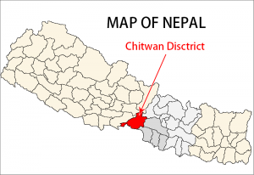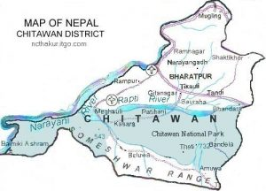prevalent in Nepali society.

**Data Source**

The data for this research project comes from two locations.

1. The first data that was collected comes from the World Bank remittance report. The report is a excel file that shows remittance received by each country globally from 1970 to 2018. The World Bank estimates remittances flow globally and bilaterally based “on national balance of payments statistics produced by the central banks and compiled by the IMF.”[11] The World Bank estimates are large datasets covering most countries around the world, from which we isolated the research points for Nepal for the purpose of this paper. However, it is important to note that these estimates are far from accurate due to methodological challenges, and only provides a general idea of the remittance trend for the country. Moreover, when comparing remittances across time it is necessary to realize that the growth in remittances may have come from changes in how remittances are calculated. Lastly, we need realize that the remittance calculated in the World Bank Statistics only considers remittance transferred through established channels such as banks and does not account for all money transfers via Western Union, post office, informal exchange, etc.[12]
2. Our second data set comes from the Chitwan Valley Family Study (CVFS): Labor Outmigration, Agricultural Productivity, and Food Security as part of the Program in Society, Population, and Environment from the Institute for Social Research at the University of Michigan. The data-set that we used to conduct this research looks at “household agriculture and Migration Survey that includes information on household agricultural practices and remittances received by the household.” Topics of the survey includes “crop production and farm technology use, wealth, assets, income, consumption, food insecurity, and information about each household member who is currently away from home. The survey also collected information on gender, ethnicity, and age.”[13]

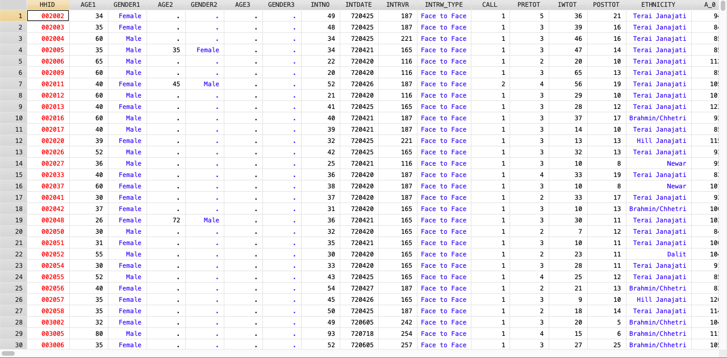**Variables**

Example of how the data was received

Codebook

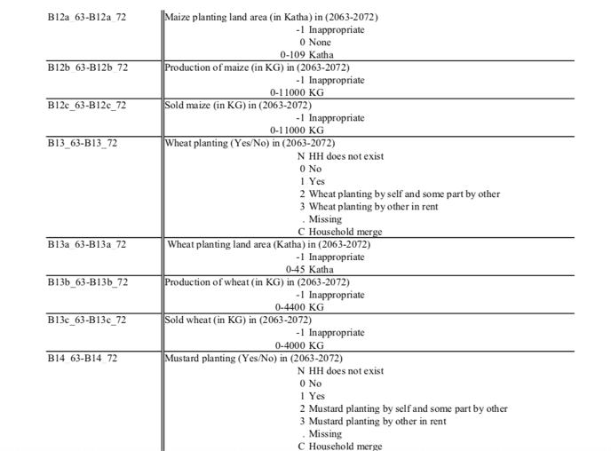 The variables we wanted to investigate for the purpose of this research were the agricultural crops that are generally produced in the Chitwan Valley. By looking at the production rate in the ten years that this data was collected and the number of migrants that have left each household as well as the remittances received by each family, we wanted to see whether the agriculture production in the area would increase or decrease? Therefore, the **dependent variables** we were looking at were *total production of crops*, which we calculated by tallying all the crops produced in Chitwan Valley. Additionally, we wanted to see what degree of affect migration and remittance had on individual crops that are mostly produced in the area- so some of other dependent variables included- *rice, wheat, mustard, and buckwheat*. By looking at individual dependent variable we were curious to investigate which crop was affected the most. Since we were looking at the effect of *Migration and Remittance*, our **independent variables** were *Migration and Remittance*. However, we wanted to **control** for *ethnicity* to see if migration, remittance and ethnicity impacted crop production at all.

**Methodology**

1. Kollmair, M; Manandhar, S; Subedi, B; Thieme , S (2006). New figures for old stories: migration and remittances in Nepal. Migration Letters, 3(2):151-160, page 152
2. http://www.pewresearch.org/fact-tank/2018/01/29/remittances-from-abroad-are-major-economic-assets-for-some-developing-countries/
3. Kollmair, M; Manandhar, S; Subedi, B; Thieme , S (2006). New figures for old stories: migration and remittances in Nepal. Migration Letters, 3(2):151-160, page 1.
4. ibid
5. <http://www.fao.org/nepal/fao-in-nepal/nepal-at-a-glance/en/>
6. <https://www.usaid.gov/nepal/agriculture-and-food-security>
7. Gauchan, Devendra, Agricultural Development in Nepal: Contribution to Economic Growth, Food Security and Poverty, December 2007
8. <http://www.thenewhumanitarian.org/report/97321/analysis-trouble-nepal%E2%80%99s-agriculture>
9. Bandhari *Agricultural Change, Outmigration and Food Security, Workshop on Integrating Social and Agricultural Science: Building Foundation for Interdisciplinary Research in Nepal*. Nob 30, 2004. Lalitpur, Nepal.
10. Singh, K.M, Jha, Awadhesh, and Singh, R K. P, *Effect of Migration on Agricultural Productivity and Women Empowerment in Bihar.* SSRN Electronic Journal. July 2012. DOI: 10.2139/ssrn.2111155
11. <https://migrationdataportal.org/themes/remittances#data-sources>
12. <https://migrationdataportal.org/themes/remittances#data-sources>
13. <https://www.icpsr.umich.edu/icpsrweb/ICPSR/studies/36755/summary>